**DESIGN AND IMPLEMENTATION OF A GSM BASED STREET LIGHT AUTOMATION SYSTEM**

BY

**DONGO YANNICK MEZIFO**

**12CK013851**

**A PROJECT REPORT SUBMITTED TO THE DEPARTMENT OF ELECTRICAL AND INFORMATION ENGINEERING, IN PARTIAL FULFILLMENT OF THE REQUIREMENTS FOR THE AWARD OF BACHELOR OF ENGINEERING DEGREE**

**(INFORMATION AND COMMUNICATION ENGINEERING)**

**SUPERVISOR: Dr Anthony. U. ADOGHE**

**APRIL 2017**

# **DECLARATION**

I hereby declare that I carried out the work reported in this project report in the Department of Electrical and Information Engineering, Covenant University, under the supervision of Dr Anthony U. Adoghe. I also solemnly declare that to the best of my knowledge; no part of this report has been submitted here or elsewhere in a previous application for the award of degree. All sources of knowledge used have been duly acknowledged.

**DONGO YANNICK MEZIFO**

**(12CKO13851)**

# **CERTIFICATION**

This is to certify that the project titled “GSM Based Streetlight Automation System” by Dongo Yannick Mezifo meets the requirements and the regulations governing the award of the Bachelor of Engineering (B.Eng.) Information and Communication Engineering degree of Covenant University and is approved for its contribution to knowledge and literary presentation.

Supervisor: Sign _____________________ Date_________________

**Name: Dr ANTHONY U. ADOGHE**

Head of Department: Sign ______________________ Date_________________

**Name: Dr VICTOR O. MATTEWS**

Internal Examiner: Sign _____________________ Date_________________

**Name:**

External Examiner: Sign ______________________ Date_________________

**Name:**

# **DEDICATION**

I dedicate this report to the Almighty God for all his undeserving favour and mercy I continually enjoy. I would also like to dedicate it to my family, both linear and extended for all the sacrifices they continually make for me. May I continually make you proud.

# **ACKNOWLEDGEMENT**

There are so many people who have in some way or the other contributed to making this project a success. I would like to express my gratitude to them.

I would like to thank my project supervisor Dr Anthony Adoghe for his counsel, guidance and patience.

I am appreciative of my parents who bore the cost of the project, and also the rest of the family who were always supportive and encouraging. I am grateful for your prayers.

I am deeply grateful to all my lecturers over the course of the last five (5) years. This project is a cumulation of what I have been able to derive from the knowledge you have impacted. Both theoretical and practical knowledge gained from some courses where invaluable to this project.

My colleagues have also helped. I would like to appreciate all the assistance they rendered, especially in troubleshooting whenever there seemed to be a problem.

Finally, I am grateful to the Almighty God for preservation throughout the duration of the program.

# **ABSTRACT**

The global demand for energy is ever increasing and there is general inability of supply to meet up with this demand coupled with the great expense of generating this energy, this means that energy conservation, in whatever amounts is becoming more crucial. Studies have shown that streetlighting alone could account for up to forty (40%) of a city’s energy budget. The current streetlight systems tend to consume too much energy and stay on for too long thus making it imperative to develop a more power optimised and easily monitorable system.

This project employs a simple methodology, SMS capability of the GSM is used to send text messages, the microcontroller fetches the text message and automates the correct relay, which in turn switches on or off the lights in the designated area.

This project, constructed with Covenant University SmartCampus initiative in mind was successfully executed. The results from the project show that an inexpensive piece of equipment such as a microcontroller can be used to automate streetlights, this automation ensures more efficient monitoring and better control thus leading to better power conservation in streetlighting.

# **LIST OF FIGURES**

Figure 1.1 Project Methodology 4

Figure 2.1 GSM Architecture 12

Figure 3.1: The Block Diagram of the entire system 30

Figure 3.2 Flowchart of the System 31

Figure 3.3 Circuit Diagram of a GSM Based Streetlight Automation System 32

Figure 3.4 The Arduino Uno Microcontroller 33

Figure 3.5 A GSM Shield SIM900 35

Figure 3.6 Pin Layout of the GSM Shield SIM900 35

Figure 3.7 A picture of an AC-DC power supply 38

Figure 3.8 Block Diagram showing the different stages of the power supply unit 39

Figure 3.9 System Power Supply Circuit 40

Figure 3.10 Pin Diagram of an LCD 42

Figure 3.11 A Four Channel Relay 42

Figure 3.12 A Relay showing all constituent parts 44

Figure 3.13 Light Emitting Diodes (LED) 45

Figure 4.1 A screenshot of Code testing using Serial Monitor on the Arduino IDE 49

Figure 4.2 A screenshot showing use of Proteus 8 software to test the schematic 50

Figure 4.3 A picture of unit testing the GSM module power supply to ensure its up to 5V 51

Figure 4.4 A picture showing the total system Integration Test 52

# **LIST OF TABLES**

Table 2.1 Comparison energy consumption between LED and other types of lamps 10

Table 3.1 Technical Specifications of Arduino Uno 34

Table 3.2 Some AT commands and their description 37

Table 3.3 Table showing Pin Descriptions of an LCD 41

Table 4.1 A Table showing the Specifications of different Components used in this project 48

Table 4.2 Bill of Engineering Measurement and Evaluation (BEME) 53

# **ABBREVIATIONS**

LED Light Emitting Diode

LCD Liquid Crystal Display

AC Alternating Current

DC Direct Current

SMS Short Messaging Service

SMSC Short Messaging Service Centre

HLR Home Location Register

SIM Subscriber Identification Module

GSM Global System for Mobile Communication

3GPP Third generation Partnership Project

ETSI European Telecommunications Standard Institute

WSN Wireless Sensor Network

DTMF Dual Tone Multi Frequency

RFID Radio Frequency Identification

PWM Pulse Width Modulation

UART Universal Asynchronous Receiver/Transmitter

Table of Contents

DECLARATION i

CERTIFICATION ii

DEDICATION iii

ACKNOWLEDGEMENT iv

ABSTRACT v

LIST OF FIGURES vi

LIST OF TABLES vii

ABBREVIATIONS viii

CHAPTER ONE 1

1.0 Background Information 1

1.1 Problem Statement 1

1.2 Research Questions 2

1.3 Motivation and Significance 3

1.4 Aim and Objectives 4

1.4.1 Aim 4

1.4.2 Objectives 4

1.5 Methodology 4

1.6 Thesis Organization 5

CHAPTER TWO 7

2.0 Introduction 7

2.1 History of Streetlights. 7

2.2 Gsm Technology 10

2.2.1 GSM Services 12

2.2.2 Short Message Service (SMS) 13

2.2.3 Why is SMS messaging so successful worldwide? 14

2.2.4 SMS Service Providers (SMS Gateway Providers, SMS Resellers, SMS Brokers) 15

2.2.5 Short Message Service Centre (SMSC) 16

2.2.6 Short Message Peer to Peer Protocol 16

2.3 Previous Work Done in The Field 17

2.3.1 Alternative Implementations of Smart Streetlight systems. 17

2.3.1.1 Automatic street light control system using LDR: 17

2.3.1.2 Control of Streetlighting Using RTC and Microcontrollers: 17

2.3.1.3 GSM Based Remote Control System of Intelligent Street Lighting System Using Zigbee : 18

2.3.1.4 GSM based RFID approach to automatic street lighting system: 19

2.3.1.5 Wireless Sensor Network for Intelligent Streetlight Systems: 19

2.3.1.6 Dynamic Public Lighting (DYNO): 20

2.3.1.7 Tyco Electronic systems: 20

2.3.2 Companies working on similar technology 21

2.3.2.1 IoTcomm Technologies, China 21

2.3.2.2 Echelon International, USA 22

2.3.2.3 Instruments Universal, India 22

2.3.3 Other Applications of GSM based Control Systems 22

2.3.3.1 GSM SMS based Wireless Notice board with Monitoring system 22

2.3.3.2 Design and Implementation of Weather Monitoring and Controlling System 23

2.3.3.3 Development of a data acquisition and greenhouse control system based on GSM 24

2.3.3.4 Gsm Based Security System 25

2.3.3.5 Automated Toll Plaza Using RFID and GSM 26

2.3.3.6 Microcontroller Based LPG Gas Detector Using Gsm Module 27

CHAPTER THREE 29

3.0 Introduction 29

3.1 System Description 29

3.1.1 Working Principle 29

3.2 Hardware Considerations 33

3.2.1 Microcontroller: The Arduino Uno 33

3.2.2 GSM Shield SIM900 34

3.2.3 Power Supply 38

3.2.4 16x2 Liquid Crystal Display(LCD) 40

3.2.5 Four (4) Channel Relay 42

3.2.6 Light-emitting diode (LED) 45

3.3 CONCLUSION 46

CHAPTER FOUR 47

4.0 Introduction 47

4.1 Overview of Implementation Phase 47

4.2 Specification 48

4.3 Testing 49

4.3.1 Software Testing 49

4.3.2 Hardware Testing 50

4.4 Packaging 52

4.5 Bill of Engineering Measurement and Evaluation (BEME) 53

4.6 Observed Precautions 54

4.7 Conclusion 54

CHAPTER FIVE 55

5.0 Summary 55

5.1 Ethical Considerations 55

5.2 Achievements 55

5.3 Challenges Encountered 56

5.4 Experience Gained 56

5.5 Recommendations 57

5.6 Conclusion 57

REFERENCES 58

APPENDIX A-1

# **CHAPTER ONE**

**INTRODUCTION**

* 1. **Background Information**

Man, throughout time has always sought to improve his efficiency, his effectiveness, to use less to achieve more, to increase his downtime whilst increasing his productivity. To achieve this, man has often had to develop technology. The more advanced the technology, the less input man has to contribute to reap more rewards.

The idea of designing a new system for the streetlight that does not consume huge amount of electricity and illuminate large areas with the highest intensity of light is concerning each engineer working in this field. Providing street lighting is one of the most important and expensive responsibilities of a city. Lighting can account for 10–38% of the total energy bill in typical cities worldwide [1]. Street lighting is a particularly critical concern for public authorities in developing countries because of its strategic importance for economic and social stability. Inefficient lighting wastes significant financial resources every year, and poor lighting creates unsafe conditions. Energy efficient technologies and design mechanism can reduce cost of the street lighting drastically.

* 1. **Problem Statement**

With the ever-increasing world demand for energy and accompanying heavy cost of energy generation and general inability of energy generation systems to meet the demands, energy conservation is becoming increasingly more crucial.

According to studies, lighting accounts for about five to fifteen percent (5%-15%) of domestic electricity bills [2]. This could rise to thirty percent (35%-39%) in office environments [3, 4] and fifty percent (50%) in industrial areas. This illustrates just how costly lighting alone can be. Outdoor halogen security lights are usually fitted with at least a 150-watt bulb, and often as high as 500-watts. Street lights can consume as much as forty percent (30-40%) of a city’s energy budget [5, 6]. They also tend to consume too much energy and stay on for too long, making them both expensive to run and leads to a short useful lifespan of the bulbs.

Streetlights are very inefficient devices, consuming a great deal of energy even when the energy is not being used. Streetlights also give off ${CO}_{2}$ emissions. The process of monitoring and control of street lights is a very manual chore that relies heavily on human intervention to detect streetlights that have faults and fallen short of operational conditions. This is a very exerting and time consuming process that involves going to each street light to ensure its in great working condition.

Manual control is prone to errors and leads to energy wastages. Also, dynamically tracking the light level is manually impracticable. The current trend is the introduction of automation and remote management solutions to control street lighting.

Therefore, there is a need to design a system to optimize streetlights energy consumption as well as reduce manual monitoring and control.

* 1. **Research Questions**

The problem statement has highlighted the deficiencies of the currently employed streetlighting systems and has prompted these questions;

* How can automation be applied to streetlighting systems?
* Is it possible to optimize power consumption of streetlights?
* Can the monitoring of the street light system be more efficient?
  1. **Motivation and Significance**

The motivation behind this project is the realization of the deficiencies within the current streetlight systems and also the realization that I could provide/ a solution that would go some way in ameliorating these deficiencies. The fact that I would also be helping the environment and help reduce the amount of ${CO}_{2}$ emissions also motivated me.

The significance of this project includes:

* Ease of monitoring and control as streetlights can be remotely controlled from anywhere in the globe.
* This solution saves time and energy required for manual monitoring and control of streetlights.
* This solution contributes to Covenant University SmartCampus initiative.
* This solution will aid in conservation of energy in streetlights.
* The conserved energy can be used to serve other functions.
* This solution would lead to reduction in light pollution due to streetlights.
* This solution would reduction in ${CO}_{2}$ emissions due to streetlights.
* This solution extends lifetime of streetlights.
* This solution leads to reduction in cost of replacing streetlights due to increased lifetime.
* This solution leads to reduction of cost of monitoring and control of streetlights.
  1. **Aim and Objectives**
     1. **Aim**

This project is aimed at the design and construction of the prototype of a smart streetlight system that can be monitored and controlled via a GSM module using SMS.

* + 1. **Objectives**

The objectives of the project are to:

* Design and construct a system to wirelessly control streetlights.
* To be able to correctly control streetlight state (on or off) via SMS messages.
* To be able to view and monitor current system state through an LCD.
  1. **Methodology**

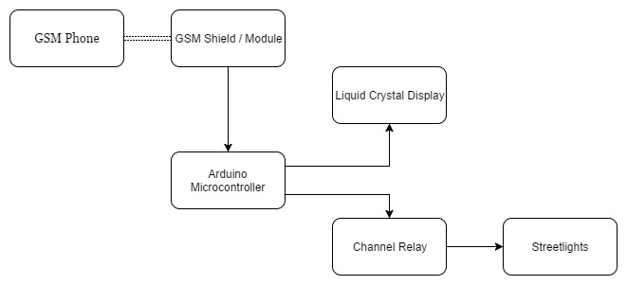

Figure 1.1 Project Methodology

The methodology that would be employed in achieving this project is quite simple.

A GSM phone sends carefully formatted commands as an SMS message to the sim card inserted in the GSM Shield. The microcontroller reads this SMS message and checks to see if it is an accepted command. If the command is invalid, the microcontroller does nothing but if the command is valid, the microcontroller carries out the command and then switches the appropriate relay in the four channel relay. This turns on or off the streetlights in the area attached to that particular relay. The microcontroller then sends an update to the LCD so that the monitoring screen shows which areas are on or off.

* 1. **Thesis Organization**

This thesis for the design and construction of a GSM based monitoring and control of streetlight has been organized with the following framework.

**Chapter One-** Introduction. This is the introductory chapter that provides detailed insight about the project. It provides the background for the project, the problem statement and its proposed solution, what serves as a motivation of the project, the significance of this project as at this time and what the project aims to achieve on its successful conclusion.

**Chapter Two**- Literary Review. The literary review serves the purpose of providing context for the project with regards to existing literature relating to this project. Previously existing knowledge, information and contributions are analysed.

**Chapter Three**- System Design. The system designed is analysed. Here the different operational modes, stages of operation, detailed description of each component used in the design and implementation of the system is given a concise description that explains their functions.

**Chapter Four**- Implementation and Testing. Here all the calculations, methodology, system construction decisions and implementation steps are explained and shown. Any tests carried out are explained, results are revealed and discussed and commented on.

**Chapter Five**- Conclusion. This is the concluding chapter where the major aims of the study are spelt out, the highlights of the previous chapters are summarized. The achievements of the thesis are also revealed and recommendations are mad for carrying out similar projects or future improvement on the project.

# **CHAPTER TWO**

**LITERATURE REVIEW**

2. 1. **Introduction**

This chapter deals with the academic and technical review of the project. It starts by giving a history of streetlight technology and then goes on give a detailed walkthrough of communication with respect to GSM and SMS technologies it then finishes by reviewing existing GSM based communication projects as well as how other street light automation systems can be realized without using GSM technology.

* 1. **History of Streetlights.**

A street light, light pole, lamppost, street lamp, is a raised source of light on the edge of a road or walkway. Lack of natural light during night time in the urban environment has always been a problem. From basic inconvenience of reducing visibility causing inability of people to see where they are going to the greater chance of being attacked or mugged during the night [7, 8]. Streetlights serve the purpose of providing lighting in order to create a lightened environment which in turn contributes to the safe and comfortable movement of vehicle and pedestrians during the hours of darkness. Road accidents and criminal activities can be reduced to a great extent when these requirements are provided [9].

The history of street lights is disputed. There are reports that street lights were used in the Arab empire as early as 9th and 10th centuries while there are others that argue it was used in Antioch as early as 4th century [7]. In 1417, in London, the then Mayor; Henry Barton ordered lanterns to be hung out during the summer evenings. In the USA, Philadelphia is considered to be the birthplace of streetlight due to its introduction and use by scientist Benjamin Franklin. In terms of technology applied, the earliest streetlights were vegetable oil lamps hung in front of homes in Rome. These homes were for the rich who had special slaves assigned to light them, watch them and extinguish them [10]. The rich in London once employed the use of *“link boys”* which were child servants that were paid to carry torches while accompanying them through the city. It is also reported that in Peking as early as 500BC, natural gas was led through bamboo pipes from volcano gas leaks to the streets of to serve as fuel for street lamps [8]. The Benjamin Franklin streetlight which were used in the colonial era were lit by candles placed inside a glass vessel, which kept the candle from being blown out by wind. Franklin's design was four‐sided, with four separate panes of glass, so that if one pane of glass was broken, the lamp did not need to be entirely replaced, and might not even blow out.

William Murdock ushered in the era of efficient lighting when he lit a gas light fuelled with coal gas during a public presentation in 1802 [8]. Paris started gas illumination of its streets in 1820, gas was led through pipes that were installed to gas lamps placed on poles. *“Lamplighters”* were employed whose jobs were to light the lamps at night and extinguish them in the morning. A lightning mechanism was later invented. Paris also claims to be home to the world’s first electric streetlights as in 1878 arc lamps called “*Yablochkov candles”* were installed. By 1881, about 4000 arch lamps were in use replacing gas lanterns on poles.

Thomas Edison pioneered the use of electric lamps when he created the carbon-thread incandescent lamp which was introduced in 1879. In Europe, there was introduction of low-pressure sodium lamps as early as 1930s. These lamps included a removable outer jacket and a vacuum layer for insulation, maintaining a high temperature to keep the sodium in vapor form. In 1962, Nick Holonyak Jr, developed the first practical visible spectrum light-emitting diode (LED). In 1965, high pressure sodium(HID) lamps produced superior colour and efficiency compared to low- pressure sodium lamps.

Modern LEDs are longer lasting, produce better light and use less energy than HID lamps but HID lamps are still the most widespread type of streetlight in use over the world [10]. The main reason LED is chosen is to reduce the energy consumption as it is very effective in lighting and low light decay in the lifetime. The LEDs have about 110° light emission angle. Meanwhile, the conventional lamps usually have 360° and need a reflector to direct the light beam to the target. Table 2.1 shows the comparison between LED and another type of lamps used in existing street lighting.

Table 2.1 Comparison energy consumption between LED and other types of lamps

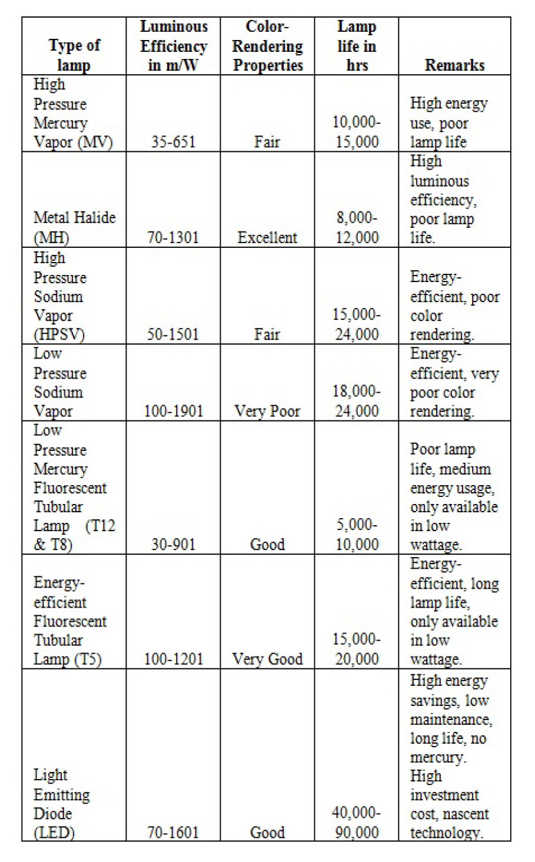

* 1. **Gsm Technology**

GSM is a global system for mobile communication GSM is an international digital cellular telecommunication. The GSM standard was released by ETSI (European Standard Telecommunication Standard) back in 1989. The first commercial services were launched in 1991 and after its early introduction in Europe; the standard went global in 1992. Since then, GSM has become the most widely adopted and fastest-growing digital cellular standard, and it is positioned to become the world’s dominant cellular standard.

Today’s second-generation GSM networks deliver high quality and secure mobile voice and data services (such as SMS/ Text Messaging) with full roaming capabilities across the world.

GSM platform is a hugely successful technology and as unprecedented story of global achievement. In less than ten years since the first GSM network was commercially launched, it become, the world’s leading and fastest growing mobile standard, spanning over 173 countries. Today, GSM technology is in use by more than one in ten of the world’s population and growth continues to sour with the number of subscriber worldwide expected to surpass one billion by through end of 2003. Today’s GSM platform is living, growing and evolving and already offers an expanded and feature-rich ‘family’ of voice and enabling services.

The Global System for Mobile Communication (GSM) network is a cellular telecommunication network with a versatile architecture complying with the ETSI GSM 900/GSM 1800 standard. Siemen’s implementation is the digital cellular mobile communication system D900/1800/1900 that uses the very latest technology to meet every requirement of the standard.

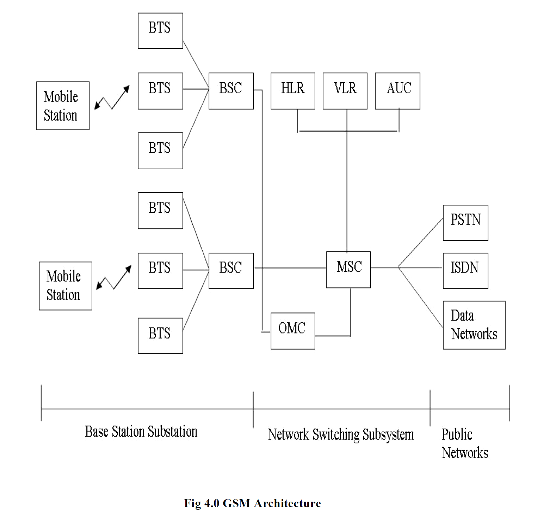

Figure 2.1 GSM Architecture

* + 1. **GSM Services**

GSM services follow ISDN guidelines and classified as either tele services or data services. Tele services may be divided into three major categories:

* Telephone services, include emergency calling and facsimile. GSM also supports Videotex and Teletex, though they are not integral parts of the GSM standard.
* Bearer services or Data services, which are limited to layers 1, 2 and 3 of the OSI reference model. Data may be transmitted using either a transparent mode or non-transparent mode.
* Supplementary ISDN services, are digital in nature, and include call diversion, closed user group, and caller identification. Supplementary services also include the short message service (SMS).
  + 1. **Short Message Service (SMS)**

SMS stands for Short Message Service. It is a technology that enables the sending and receiving of message between mobile phones. SMS first appeared in Europe in 1992. It was included in the GSM (Global System for Mobile Communication) standards right at the beginning. Later it was ported to wireless technologies like CDMA and TDMA. The GSM and SMS standards were originally developed by ETSI. ETSI is the abbreviation for European Telecommunication Standard Institute. Now the 3GPP (Third Generation Partnership Project) is responsible for the development and maintenance of the GSM and SMS standards.

One SMS message can contain at most 140 bytes (1120 bits) of data, so one SMS message can contain up to:

* 160 characters if 7-bit character encoding is used. (7-bit character encoding is suitable for encoding Latin characters like English alphabets.)
* 70 characters if 16-bit Unicode UCS2 character encoding is used. (SMS text messages containing non-Latin characters like Chinese character should use 16- bit character encoding.)

Once the message is sent the message is received by SMSC, which must then get it to the appropriate mobile device. To do this the SMSC sends a SMS request to Home Location Register (HLR) to find the roaming customer. Once HLR receives the request, it responds to the SMSC with the subscriber’s status:

* Inactive or active
* Where subscriber is roaming

If the response is “inactive”, then the SMSC will hold onto the message for a period of

time. When the subscriber access his device, the HLR sends a SMS notification to the

SMSC and the SMSC will attempt delivery. The SMSC transfer the message in a Short Message Delivery Point to Point format to the serving system. The system pages the device, and if it responds, the message gets delivered. The SMSC receives verification that the message was received by the end user, then categorizes the message as “sent” and will not attempt to send again. SMS provides a mechanism for transmitting short message to and from wireless devices.

The service makes use of an SMSC, which acts as a store and forward system for short

messages. One major advantage of SMS is that it is supported by 100% GSM mobile phones. Almost all subscription plans provided by wireless carriers include inexpensive SMS

messaging service.

* + 1. **Why is SMS messaging so successful worldwide?**

SMS is so successful all over the world. SMS messaging is now one of the most important

revenue sources of wireless carriers. Some of the reasons are discussed below.

* SMS Messages can be sent and read at any time
* SMS Message can be sent to an offline Mobile Phone.
* SMS Messaging is less disturbing while you can still stay in touch.
* SMS are supported by 100% GSM Mobile Phones and they can be Exchanged between different wireless carriers
  + 1. **SMS Service Providers (SMS Gateway Providers, SMS Resellers, SMS Brokers)**

There is a demand for SMS connectivity from applications that does not require the sending or receiving of large amount of SMS messages. One example is a remote monitoring system. If the remote monitoring system finds that a certain server is not responding, it will send an SMS alert to the system administrator mobile phone. This remote monitoring system will have a very small amount of SMS traffic per month since the servers being monitored should be working fine most of the time. Since a wireless carrier usually doesn’t provide direct SMSC or SMS gateway access to user without a large amount of SMS traffic, some companies come out to fill the gap. These companies are called SMS service providers.

SMS service providers are also known as SMS gateway providers, SMS resellers and SMS brokers because of the following reasons:

* SMS gateway providers-: An SMS service provider provides an SMS gateway for
* its user to send SMS message to. This SMS gateway will then route the SMS
* message to another SMS gateway or SMSC.
* SMS reseller and SMS broker-: SMS service provider buy a large amount of SMS
* message from a lot of wireless carrier at low price per SMS message. They then
* sell the SMS message at a price higher than the cost.

Another advantage of using the SMS connectivity services of SMS service providers is that their network coverage is very good. They work hard to cover as many wireless networks as possible so as to make their services attractive.

* + 1. **Short Message Service Centre (SMSC)**

SMSC is a combination of hardware and software responsible for the relaying and storing and forwarding of short message between an SME and mobile device. The SMSC must have high reliability, subscriber capacity, and message throughput. In addition, the system should be easily scalable to accommodate growing demand for SMS in the network. Normally, an IN-based solution will allow for a lower entry cost compared to point solutions because it can support other applications on single hardware platform and share resources, thereby spreading the deployment cost over several services and applications.

Another factor to be considered is the ease of operation and maintenance of the application, as well as the flexibility to activate new services and upgrade to new software releases.

* + 1. **Short Message Peer to Peer Protocol**

The short message peer to peer protocol (SMPP) is a protocol for exchanging SMS messages between SMS peer entities such as message service centers. It is often used to allow third parties (e.g. content suppliers like news organizations) to submit messages, often in bulk.

The protocol is based on complimentary pairs of request / response PDUs exchanged over OSI layer 4 (TCP/IP session or X.25 SVC3) connections. PDUs are binary encoded for efficiency.

* 1. **Previous Work Done in The Field**
     1. **Alternative Implementations of Smart Streetlight systems.**
        1. **Automatic street light control system using LDR:**

Due to the busy nature of human life, people are finding it increasingly more difficult to remember to switch on streetlights when not necessary. This system will ensure streetlights will switch on in the evening and be switched off in the morning when there is sufficient lamination. Two sensors are used which are light dependent resistor LDR sensor to indicate a day/night time and the photoelectric sensors to detect the movement on street. The microcontroller PIC16F877A is used as brain to control the street light system. The light sensor will detect darkness to activate the ON/OFF switch, so the streetlights will be ready to turn on the photoelectric sensor will detect movement to activate the streetlights. LDR, which varies according to the amount of light falling on its surface, this gives an indication for whether it is a day or night time, the photoelectric sensors are placed on the side of the road, which can be controlled by microcontroller PIC16f877A.The photoelectric will be activated only on the night time. If any object crosses the photoelectric beam, a particular light will be automatically ON [11].

**Criticism of this model:** The drawback to this method is the event any shadow of sufficient intensity falls on the LDR, by virtue of an obstruction or any other means, it would to the turning on of the streetlight even when it is not nightfall or not needed

* + - 1. **Control of Streetlighting Using RTC and Microcontrollers:**

This system employs microcontrollers such as PIC16F877A or Atmel Atmega or even an 8051 microcontroller. The microcontroller is fitted with a real-time clock (RTC). A typical adoption of this system involves an RTC DS1307, a AT89S8252 microcontroller as its brain powers the RTC DS1307. At the pre-programmed On and OFF times, the Microcontroller switches the streetlights on and off respectively [12].

**Criticism of this Model:** Power failure is a huge limitation to this model because once the power is out, the Real-Time clock (RTC) loses its count and the microcontroller would fail to perform its function at programmed time. Also if the power is out by sufficiently long, the RTC count would reset and may require being reset. This model can be augmented by providing the RTC with a separate power source such as a 3v battery.

* + - 1. **GSM Based Remote Control System of Intelligent Street Lighting System Using Zigbee :**

The basic concept of this street light system is in the street there will be many observing stations to which collectively base station is location in nearby area to all streets. Thus each lamp post contains many sensors to observe different

factors to either to turn on or off the light. This depends on the different factors such as season, climatic conditions and geographical location and so on. In this system to main Zigbee technology is efficient and also easy to handle [13].

**Criticism of this Model:** The only criticism of this system is that it may be considered expensive in terms of resources and funds. Otherwise it’s a great system to employ in a busy city.

* + - 1. **GSM based RFID approach to automatic street lighting system:**

The main objective is to control the street lighting using Dual Tone Multi Frequency (DTMF). The Radio-frequency identification (RFID) reader is fixed in the street light and the tags are given to individual houses, the user must show his tag to the reader and the information will be intimated to the server through GSM. The engineer may respond to the issue immediately. GSM is used to transmit the data to the server like load balancing, disconnection of power and complaints. Regarding power in the houses, balancing a load is the major issue in the electricity. To overcome this problem current transformer is used. The function of current transformer is used to send the load details continuously to controller. Already the loads values are predefined in the microcontroller are compared with the present value. If the values are more than the predefined values, it will automatically send a message through GSM [11].

**Criticism of this model:** The use of Radio Frequency Identification tags may be considered an overkill. Each household should not be in charge of ensuring the streetlights should be on and off as security works best together in a system and not individually.

* + - 1. **Wireless Sensor Network for Intelligent Streetlight Systems:**

Wireless Sensor Network (WSN) is a wireless network consisting of spatially distributed autonomous devices using sensors to cooperatively monitor physical or environmental conditions, such as temperature, sound, vibration, pressure, motion or pollutants, at different locations In addition to one or more sensors, each node in a sensor network which typically equipped with a radio transceiver or other wireless communications device, a small microcontroller, and an energy source, usually a battery.

A sensor network normally constitutes a wireless ad-hoc network, meaning that each sensor supports a multi-hop routing algorithm (several nodes may forward data packets to the base station).

**Criticism of this Model:** Much like the Zigbee system, the only criticism of this system is that it may be considered expensive in terms of resources and funds. Otherwise it’s a great system to employ in a large metropolitan area.

* + - 1. **Dynamic Public Lighting (DYNO):**

In Netherlands, the system installed and operated is a dynamically lighted roadway that can be adjusted to any of three lighting levels, depending on the amount of traffic, time of day, and weather conditions. The low level is 0.2 cd/m2, the normal level is 1 cd/m2 and the high level is 2.0cd/m2. The wireless communication uses frequency band of 900 MHz which ultimately results in lower data communication rate. In an evaluation of DYNO, it was concluded that, under low traffic volume and favourable weather conditions, the low level (0.2 cd/m2) can be applied [14].

**Criticism of this Model:** This system is suitable for large cities with high traffic density. It also requires a large cost outlay.

* + - 1. **Tyco Electronic systems:**

An “Intelligent Street Lighting and Street Light Monitoring” system has been developed which maximizes energy saving and minimizes unwanted light (as light pollution), but takes account of the environment and safety standards needed in all traffic conditions. The energy saving is achieved by driving each light source to the minimum illumination, needed for specific time and weather conditions. Planned settings can be overruled by environmental conditions such as heavy rain, visibility, frost, traffic density and much more. The requirement for the light level needed during each condition can be predefined [14].

**Criticism of this Model:** This system is suitable for large cities with high technological requirements. It involves tremendous cost outlay.

* + 1. **Companies working on similar technology**
       1. **IoTcomm Technologies, China**

IoTcomm Technologies develops communication technologies for the Internet of Things (IoT), including but not limited to Power Line Communication (PLC), GPRS, Zigbee and WIFI. By integrating PLC and wireless communication technologies seamlessly, Dotcom has developed an intelligent street lighting control and management system, which provides its customers with the least expensive and the most reliable solution to significantly reduce power consumption, operating costs and environmental impacts. IoTcomm also offers power line communication modules and wireless communication modules, which are readily to be integrated into smart automation systems including lighting, heating and cooling, security, fire detection, access control, or energy monitoring equipment for both commercial and residential buildings [15].

* + - 1. **Echelon International, USA**

Echelon’s Smart Street Lighting Solution transforms streetlights into intelligent, energy efficient, remotely managed networks that deliver dependable lighting at 30% less cost than low-energy luminaries alone. Over the long term, Smart Street Lighting serves as a foundation for building a Smart City. Nearly 500 cities have started and know the value of it is field-proven and reliable smart street lighting solution. It has proven track record to provide safer, more affordable lighting that reduces carbon footprint [15].

* + - 1. **Instruments Universal, India**

Instruments Universal, an Industrial Automation & System Integration major in Gujarat, was established in 1980 in Vadodara. With a strong foundation of technical expertise and 30-year experience in Effluent Sampling Automation, it has emerged as one of the leading torchbearers in the Automation Industry. The company specializes in MCS51 series, ST7 series of microcontrollers, assembly languages, visual basic, Java, effective 32bit ARM processor operations and PIC microchip controllers. The company is serving in the field of street light automation, street light monitoring and controlling and street light management since 2000 [15].

* + 1. **Other Applications of GSM based Control Systems**
       1. **GSM SMS based Wireless Notice board with Monitoring system**

The main aim of this project is to design an SMS driven automatic display which reduces the manual operation of updating notice boards. The information can in turn be updated instantly at the desired location. Updates can be done in individual displays without disturbing other displays. The message to be displayed is sent as an SMS to a GSM receiver module. This message is then stored in PC and is sent to the LCD displays through the controller. The messages stored in the computer acts as a record for future reference. The entries can be documented and a record may be maintained for future use by using visual basic. The controller has internal a real-time clock used for synchronization of data. A resistive touch screen is used to access the previous notices and progress details [16].

* + - 1. **Design and Implementation of Weather Monitoring and Controlling System**

This system employs a LPC1768 which is an ARM9 microcontroller, a Humidity sensor, a Temperature Sensor, LABVIEW and a GSM Module. a single master-multi slave microcontroller communication method has been developed. The microcontroller can communicate using unicast communication, i.e. the master gave orders to one slave address via the master-slave network that has star topology. Then the slave who has the same address which is requested will respond or take action in accordance with the master command. Modbus Protocol is the rules of data communication with the master-slave technique. In these communications, there is only one master and one or several slaves which form a network. The design and implementation of weather monitoring & controlling system is the model with the ability to perform data acquisition on temperature, gas, humidity and accelerometer sensors attached. And it can give these sensors data to ADC Port of LPC1768. It can also upload the data continuously to excel sheet in LABVIEW with the help of RS232 Cable and receives SMS with the help of GSM [17].

* + - 1. **Development of a data acquisition and greenhouse control system based on GSM**

Most physical variables relevant in a greenhouse can be measured by automatic sensors. This holds for temperature, soil moisture, and relative humidity. The most important disturbance factors can be measured with sensors as well, that is, outside temperature, outside relative humidity, wind speed, and solar radiation. Precipitation can also be detected, although it is somewhat less common. All the mentioned physical variables are sampled and stored electronically at regular intervals when something is changing. Also, in principle, the control inputs are known, although it must be said that these important data are not always

recorded. Overall, the measurements provide quite a good input-output picture of the physical part of the greenhouse crop system.

A factual execution of this idea is the contribution to the development of greenhouse production in Morocco. This system presents the design and development of an electronic system based on a microcontroller that integrates remote control functions rooted in the GSM network (Adedjouma et al, 2006). The system allows the acquisition of different climatic parameters in an agricultural greenhouse. In addition, this electronic system achieves the control and remote monitoring of greenhouse solutions, drip irrigation in particular stations, by sending SMS messages (Lajara et al, 2011; Luthra et al, 1997). The system, also, includes a serial cable, a GSM, conditional sensors card, power interfaces and microcontroller. An active SIM card is required to receive and send messages. A graphical user interface can be created using LabVIEW software for the acquisition, monitoring with PC and storage of all data through the PCL812PG card. This interface encompasses at the same time reliability, flexibility of use, interactivity and processing capability in real-time of the whole data. Our systems present several advantages: i) user friendly; ii) easily implemented; iii) focus main parameters; iii) use GSM phones because of its ready availability; iv) relatively low cost of SMS in Morocco; and v) network coverage (3 operators existing in Morocco cover all the territory) [18].

* + - 1. **Gsm Based Security System**

The concept attempts to develop and launch an up-to-date, reliable and user friendly security system to automate home security system using microcontroller circuitry synchronized with GSM module with an objective to provide maximum possible security based on an automatic emergency care response using sensors, cameras, trapping system. The concept of trapping system is relatively new and more efficient that previously existing systems.

Hardware of the system contains sensors, Atmega8l microcontroller, sim300 (GSM module), Buzzer, in system programmer and relays to control the appliances. The system design is uses sensor and Keypad are input devices. Motor driver, GSM modem, LCD- display are used as output devices. Input is given to Microcontroller, processing device which provides output to output devices in form of instructions that are to be performed by them. Operation of the whole system gets initiated when IR sensor senses the presence of any human being within its range.

When presence of human being is sensed it sends signal to microcontroller, which reads the status of the IR sensor and switches on the keypad and LCD display. LCD display shows what has to be provided by person as input to controller in order to open the door. User then enters the required information to controller via keypad, in this case password is required to be entered. This entered password is displayed at the LCD display. If the entered password is correct then signal is sent to GSM modem via USART which further inform the owner of the house on the registered number about presence of someone near his gate by sending a predefined message and signal is also sent to microcontroller which further provide instructions to the motor driver to open door.

In case wrong password is entered three time by some intruder then also signal is sent to GSM via USART to send message of Security alert to registered user and in this case microcontroller provide instruction to motor driver to not to open the door. This helps in informing the owner of the house about the presence of some known person or some intruder around the house. USART here is used as a serial protocol for communication between microcontroller and GSM modem [19].

* + - 1. **Automated Toll Plaza Using RFID and GSM**

This concept employs ATMega328, GSM, LCD, RFID, for the automation of Toll Plazas for swift movement of traffic with the aim of saving both time and money. The RFID receiver is interfaced to the microcontroller. The receiver is Active and the RFID tags are passive. The receiver will be fixed at the toll plaza constantly trying to search for the tag. As soon as the tag comes in the range of the receiver, the unique code from the tag is identified by the receiver and transmitted serially to the microcontroller.

The controller then matches the unique code to the Central Database and checks if the owner of the tag is in good standing with respect to the balance in his account. Stipulated price of the toll will be deducted from his account. Hence a complete cashless operation is made possible. Then an SMS will be sent to the owner using the GSM module about how much money has been debited from his account OR if there is insufficient balance, the SMS will intimate him that the transaction failed. Moreover, the owner will be sent the information regarding the location of the toll plaza from where the vehicle has passed. In this way he will get a warning to maintain sufficient balance in his account and also be able to track his vehicle in case of theft. As he passes the gate he will be also able to see his details on site on the LCD on site. Accordingly, if the toll is paid properly the gate will automatically open for him [20].

* + - 1. **Microcontroller Based LPG Gas Detector Using Gsm Module**

In this concept, Ideal gas sensor is used to detect the presence of a dangerous LPG leak in your car or in a service station, storage tank environment. This unit can be easily incorporated into an alarm unit, to sound an alarm or give a visual indication of the LPG concentration. The sensor has excellent sensitivity combined with a quick response time. The sensor can also sense iso-butane, propane, LNG and cigarette smoke.

If the LPG sensor senses any gas leakage from storage the output of this sensor goes low. This low signal is monitored by the microcontroller and it will identify the gas leakage. Now the microcontroller is turn on LED and Buzzer. After few milliseconds delay, it also turn on exhaust fan for throwing gas out and continue send messages as “GAS LEAKAGE” to a mobile number, written in C-code [21].

**Table 2.2 A Table showing Comparison between different intelligent Streetlight systems**



# **CHAPTER THREE**

**SYSTEM DESIGN**

1. 1. **Introduction**

In this chapter, the various component units of the system are described and analysed. Along with the in-depth description of the various components, reasons behind choice of the individual components are stated. This chapter gives an overview of the various systems and subsystems.

* 1. **System Description**

The whole idea of this system is to be able to remotely control your streetlighting remotely, even from anywhere in the globe so long as you have GSM coverage. This system employs an Arduino microcontroller and a GSM module to remotely control streetlights. Other peripherals are also required for different reasons; PIR sensors here are used to aid conservation of power, Relays are used to drive the streetlight arrays, these relays themselves powered by an ULN2003(high voltage and high current Darlington array IC).

This whole system can be broken down to some subsystem such as power supply, the relay system, the communication system (between GSM modem and user) and the control system (microcontroller).

* + 1. **Working Principle**

The working principle of this system is quite simple.

The system administrator sends an SMS message to the SIM card slotted into the GSM module. The message must be formatted accorded to the code specified in the Microcontroller. In this case, the message begins with an “#A.” followed by the specific command and ends with a “*”. When the message does not follow this structure, the microcontroller does nothing. When the command is appropriate, the microcontroller carries out the command and updates the current system status on the Liquid Crystal Display (LCD) and then sends a confirmation text to the administrator to inform him his command has been carried out.

The following are the block diagrams and the flowchart of the system

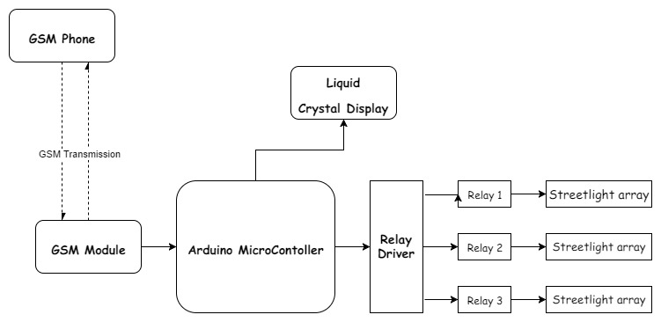

Figure 3.1: The Block Diagram of the entire system

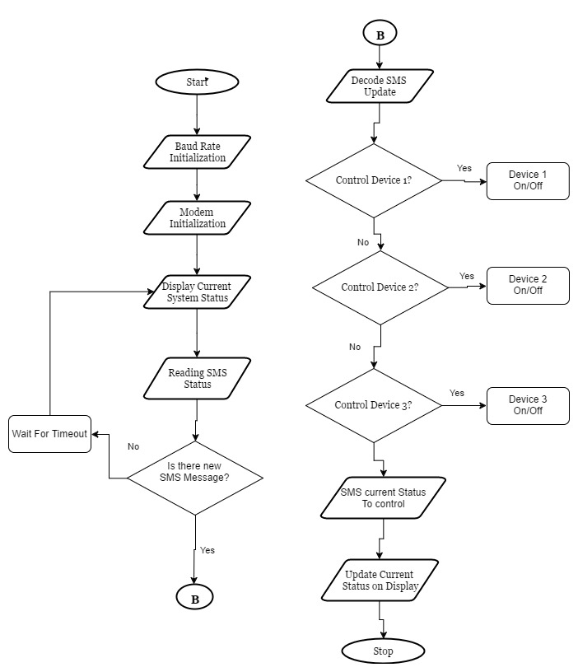

Figure 3.2 Flowchart of the System

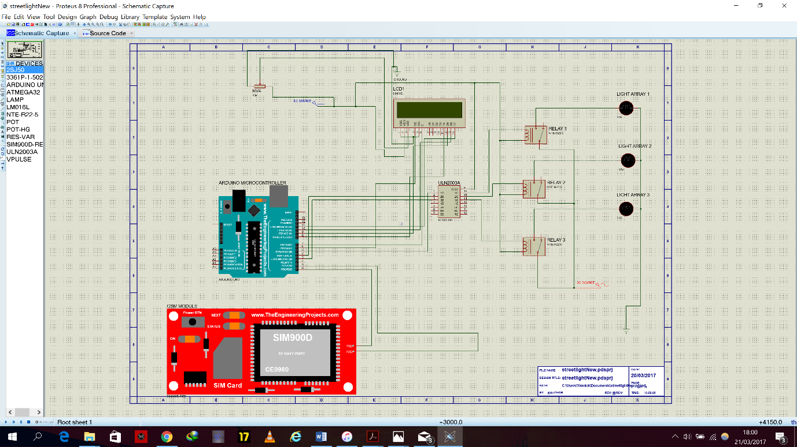

Figure 3.3 Circuit Diagram of a GSM Based Streetlight Automation System

* 1. **Hardware Considerations**
     1. **Microcontroller: The Arduino Uno**



Figure 3.4 The Arduino Uno Microcontroller

The Arduino Uno is a microcontroller board based on the ATmega328 (datasheet). It has 14 digital input/output pins (of which 6 can be used as PWM outputs), 6 analogue inputs, a 16 MHz crystal oscillator, a USB connection, a power jack, an ICSP header, and a reset button. It contains everything needed to support the microcontroller; simply connect it to a computer with a USB cable or power it with a AC-to-DC adapter or battery to get started. The Uno differs from all preceding boards in that it does not use the FTDI USB-to-serial driver chip. Instead, it features the Atmega8U2 programmed as a USB-to-serial converter [22].

Table 3.1 Technical Specifications of Arduino Uno

|  |  |
| --- | --- |
| Microcontroller | ATmega328 |
| Operating Voltage | 5V |
| Input Voltage (recommended) | 7-12V |
| Input Voltage (limits) | 6-20V |
| Digital I/O Pins | 14 (of which 6 provide PWM output) |
| Analog Input Pins | 6 |
| DC Current per I/O Pin | 40mA |
| DC Current for 3.3V Pin | 50mA |
| Flash Memory | 32 KB of which 0.5 KB used by  Bootloader |
| SRAM | 2KB |
| EEPROM | 1KB |
| Clock Speed | 16MHZ |

* + 1. **GSM Shield SIM900**

The GPRS Shield provides you a way to use the GSM cell phone network to receive data from a remote location. The shield allows you to achieve this via any of the three methods:

* Short Message
* Service Audio
* GPRS

The GPRS Shield is compatible with all boards which have the same form factor (and pinout) as a standard Arduino Board. The GPRS Shield is configured and controlled via its UART using simple AT commands. Based on the SIM900 module from SIMCOM, the GPRS Shield is like a cell phone sans the Human Machine Interface. Besides the communications features, the GPRS Shield has 12 GPIOs, 2 PWMs and an ADC [23].



Figure 3.5 A GSM Shield SIM900

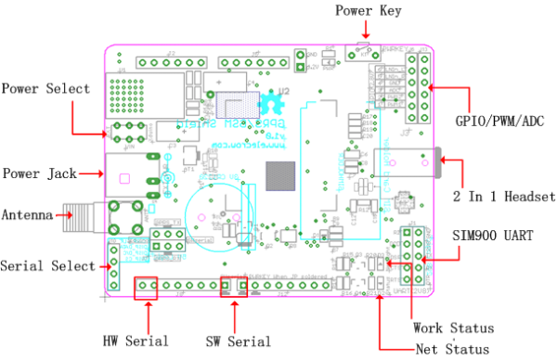

Figure 3.6 Pin Layout of the GSM Shield SIM900

**Features:**

* Fully compatible with Arduino / Uno and Mega.
* Free serial port connecting， you can select Hardware Serial port (D0/D1) control or Software Serial port (D2/D3) control it.
* SIM900 all pins breakout. Not just the UART port and debug port be layout, but also all pins on SIM900 be layout to the 2.54 standard pitch.
* Super capacitor power supply for the RTC.
* EFCom not only can use the button for power on, but also can use the digital pin of Arduino to power on and reset the SIM900 module.
* Quad-Band 850/ 900/ 1800/ 1900 MHz
* GPRS multi-slot class 10/8
* GPRS mobile station class B
* Compliant to GSM phase 2/2+
* Control via AT commands (GSM 07.07 ,07.05 and EFCOM enhanced AT Commands)
* SIM application toolkit
* Supply voltage range : 3.1 … 4.8V
* Low power consumption: 1.5mA(sleep mode)
* Operation temperature: -40°C to +85 °C
* Dimension:68.33x53.09mm(Same dimension of Arduino main board)

**AT Commands**

AT commands are guidelines used to control a modem. AT is the abbreviation of ATtention. Each command begins with “AT” or “at”. The relationship between the terminal equipment and the handset can be acknowledged with a serial link (e.g. USB), a Bluetooth link, an infrared connection, and so on. Regular AT commands include AT+CMGS (send message), AT+CMSS (send message from storage), AT+CMGL (list messages) and AT+CMGR (read message). Below is a table outlining the AT commands for sending SMS and their description.

Table 3.2 Some AT commands and their description

|  |  |
| --- | --- |
| Command | Description |
| AT | It is the prefix of every command sent to the modem. It is also used to test the condition of the modem. The GSM modem responds with an \r\nOK\r\n or an \r\nERROR\r\n in case of error.  Where \r is the carriage return character and \n is the newline feed character. |
| AT+CSMINS? | Command to check if the Modem has a SIM inserted in it. |
| AT+CREG? | Command to check if the SIM is registered with a network. It checks and then returns the status. |
| AT+CMGD | Delete SMS message. |
| AT+CMGF | Select SMS Format. |
| AT+CMGR | Read SMS message. |
| AT+CMGS | Send SMS message |
| AT+CMGS=”><INDEX>” | Send SMS message by index. |

* + 1. **Power Supply**

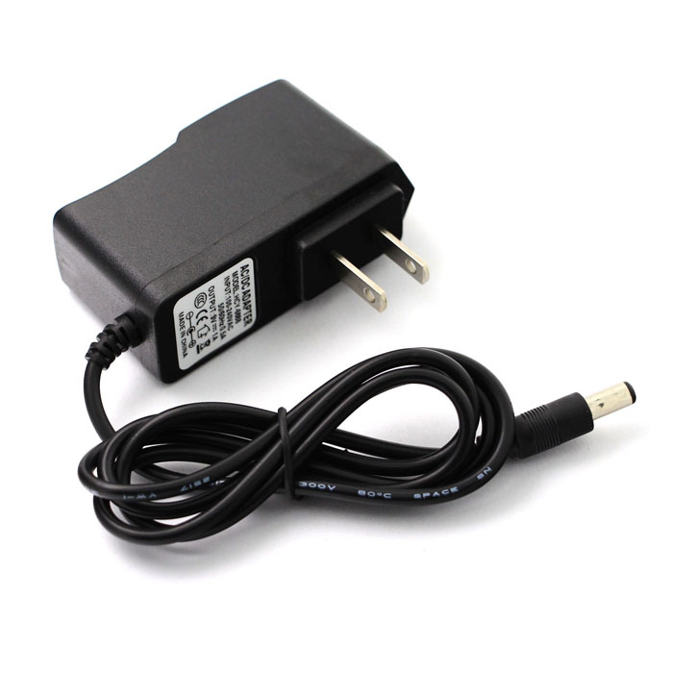

Figure 3.7 A picture of an AC-DC power supply

Power supplies or power supply units, PSU, form an essential part of very many items of electronics equipment. The most common form takes in AC power from the mains supply and delivers a DC voltage to the item requiring power.

For this project I used a AC/DC supply unit rated at 9V 1A.

Power supply is important because:

* It changes (in most cases reduces) the level of supply to a value suitable for driving the load circuit.
* It produces a DC supply from the mains (or line) supply AC sine wave.
* It prevents any AC from appearing at the supply output.
* It will ensure that the output voltage is kept at a constant level, independent of changes in:
  + The AC supply voltage at the supply input.
  + The Load current drawn from the supply output.
  + Temperature.



Figure 3.8 Block Diagram showing the different stages of the power supply unit

* + - 1. **Transformation:** The input transformer is used to transform the incoming line voltage down to the required level for the power supply. Typically, the input transformer provides a step-down function. It also isolates the output circuit from the line supply. I used a 240V to 12V transformer in this project.
      2. **Rectification:** The power supply rectifier converts the incoming signal from an AC format into raw DC. Either half wave or more commonly full wave rectifiers may be used as they make use of both halves of the incoming AC signal. In this project I employed a bridge rectifier consisting of four (4)1N4007 diodes.
      3. **Smoothing/filtering:** The raw DC from the rectifier is far from constant falling to zero when the AC waveform crossed the zero axis, and then rising to its peak. The addition of a reservoir capacitor here fills in the troughs in the waveform, enabling the next stage of the power supply to operate. Large value capacitors are normally used within this stage.
      4. **Regulation:** This stage of the power supply takes the smoothed voltage and uses a regulator circuit to provide a constant output virtually regardless of the output current and any minor fluctuations in the input level.

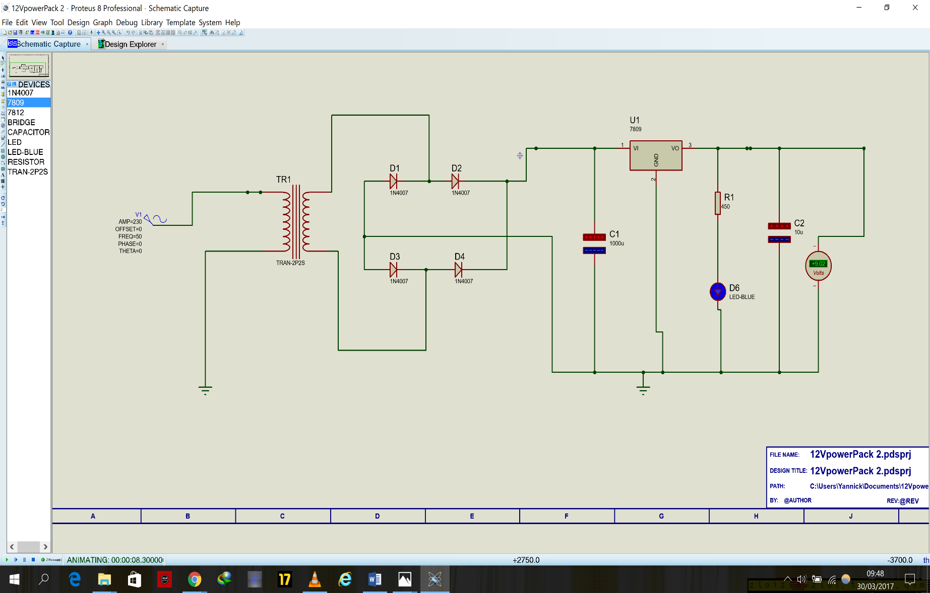

Figure 3.9 System Power Supply Circuit

* + 1. **16x2 Liquid Crystal Display(LCD)**

LCD (Liquid Crystal Display) screen is an electronic display module and find a wide range of applications. A 16x2 LCD display is very basic module and is very commonly used in various devices and circuits. These modules are preferred over seven segments and other multi segment LEDs. The reasons being: LCDs are economical; easily programmable; have no limitation of displaying special & even custom characters (unlike in seven segments), animations and so on [24].

A 16x2 LCD means it can display 16 characters per line and there are 2 such lines. In this LCD, each character is displayed in 5x7 pixel matrix. This LCD has two registers, namely, Command and Data.

The command register stores the command instructions given to the LCD. A command is an instruction given to LCD to do a predefined task like initializing it, clearing its screen, setting the cursor position, controlling display etc. The data register stores the data to be displayed on the LCD. The data is the ASCII value of the character to be displayed on the LCD. Click to learn more about internal structure of a LCD.

Table 3.3 Table showing Pin Descriptions of an LCD

|  |  |  |
| --- | --- | --- |
| **Pin No** | **Function** | **Name** |
| 1 | Ground (0V) | Ground |
| 2 | Supply voltage; 5V (4.7V – 5.3V) | Vcc |
| 3 | Contrast adjustment; through a variable resistor | VEE |
| 4 | Selects command register when low; and data register when high | Register Select |
| 5 | Low to write to the register; High to read from the register | Read/write |
| 6 | Sends data to data pins when a high to low pulse is given | Enable |
| 7 | 8-bit data pins | DB0 |
| 8 | DB1 |
| 9 | DB2 |
| 10 | DB3 |
| 11 | DB4 |
| 12 | DB5 |
| 13 | DB6 |
| 14 | DB7 |
| 15 | Backlight VCC (5V) | Led+ |
| 16 | Backlight Ground (0V) | Led- |

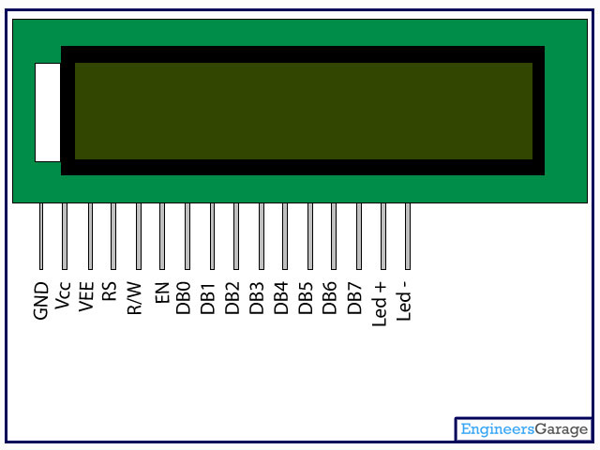

Figure 3.10 Pin Diagram of an LCD

* + 1. **Four (4) Channel Relay**

A relay is an electrically operated switch. Many relays use an electromagnet to operate a switching mechanism mechanically, but other operating principles are also used. Relays are used where it is necessary to control a circuit by a low-power signal (with complete electrical isolation between control and controlled circuits), or where several circuits must be controlled by one signal. The first relays were used in long distance telegraph circuits, repeating the signal coming in from one circuit and re-transmitting it to another. Relays were used extensively in telephone exchanges and early computers to perform logical operations [25].

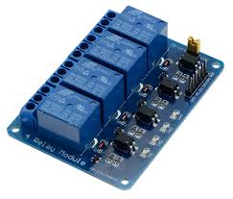

Figure 3.11 A Four Channel Relay

* + - 1. **Relay Operation**

A relay is an electromechanical switch, used to provide isolation between high and low voltage circuits. Basically, a relay switches between 5V and 220/120V circuits.

For example, in a microcontroller based circuit, the relay is used to isolate the microcontroller from the 220volt power supply. Relays are very useful in application where it is essential to control a circuit that demands a low power signal.

Every relay includes the following:

* An electromagnet which becomes a magnet after receiving an electric signal.
* An armature which the magnet attracts.
* A spring which retracts the armature once the electromagnet is demagnetized
* Sets of electrical contacts.

**Principle of Operation**

A relay is made up of two completely independent and autonomous circuits. In the first circuit, the one which derives the electromagnet, a transistor acts as a switch by regulating the power to the electromagnet. The Transistor is used to set up the current that is required to energize the coil through the collector unit. If there is no current input at the transistor base, the base current, the coil current and the collector current remains zero, and the relay stays unenergized. But once a positive voltage is inputted into the base from the microcontroller, the transistor comes ON and enough current is passed thought the coil, which in turn attracts the armature. In the second circuit, the role of the switch is taken on by the armature. With the coil energized, the second circuit is completed by the armature, thereby powering ON the appliance connected to it. Once the microcontroller sends a zero voltage pulse, the coil becomes de-energized, and the other spring retracts the armature thereby breaking the circuit, hence powering OFF the appliance

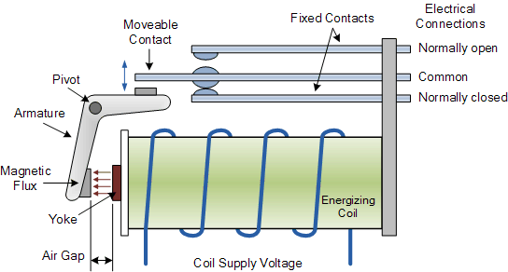

Figure 3.12 A Relay showing all constituent parts

The terminals that make up a relay are:

* Normally Open (NO) terminal: This is terminal where the divide supposed to be powered by the relay is connected to if the device is to be OFF when the relay is not powered and ON when the relay is powered.
* Normally Closed(NC) terminal: The terminal where the device is to be powered is connected to if the device is to be ON normally when the relay is not powered and OFF when the relay is powered.
* Coil terminals: These are the terminals where the voltage is applied in order to provide power to the coils.
* COM terminal: the common terminal of the relay. This is the terminal where the first part of the circuit is connected to. If the switch is closed, COM and NO have continuity, but if the switch is open, and the relay isn’t powered, then COM and NC have continuity
  + 1. **Light-emitting diode (LED)**

A light-emitting diode (LED) is a [semiconductor](http://searchcio-midmarket.techtarget.com/definition/semiconductor) device that emits visible light when an electric [current](http://searchcio-midmarket.techtarget.com/definition/current) passes through it. The light is not particularly bright, but in most LEDs it is monochromatic, occurring at a single [wavelength](http://searchnetworking.techtarget.com/definition/wavelength). The output from an LED can range from red (at a wavelength of approximately 700 nanometres) to blue-violet (about 400 nanometres). Some LEDs emit infrared ([IR](http://searchnetworking.techtarget.com/definition/infrared-radiation)) energy (830 nanometres or longer [26].

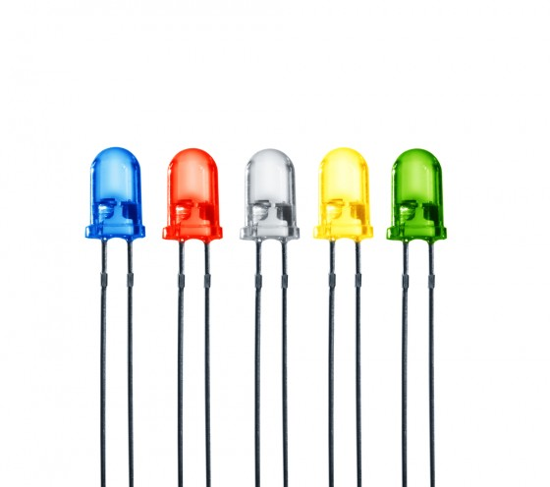 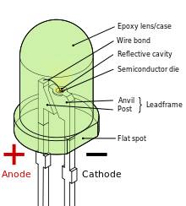

Figure 3.13 Light Emitting Diodes (LED)

An LED or consists of two elements of processed material called P-type semiconductors and N-type semiconductors. These two elements are placed in direct contact, forming a region called the P-N junction. In this respect, the LED resembles most other [diode](http://searchcio-midmarket.techtarget.com/definition/diode) types, but there are important differences. The LED has a transparent package, allowing visible or IR energy to pass through. Also, the LED has a large PN-junction area whose shape is tailored to the application.

**Benefits of LEDs**, compared with incandescent and fluorescent illuminating devices, include:

* **Low power requirement**: Most types can be operated with battery power supplies.
* **High efficiency:** Most of the power supplied to an LED is converted into radiation in the desired form, with minimal heat production.
* **Long life:** When properly installed, an LED can function for decades.

**Typical applications include:**

* Indicator lights: These can be two-state (i.e., on/off), bar-graph, or alphabetic-numeric readouts.
* LCD panel backlighting: Specialized white LEDs are used in flat-panel computer displays.
* Fibre optic data transmission: Ease of modulation allows wide communications bandwidth with minimal noise, resulting in high speed and accuracy.
* Remote control: Most home-entertainment "remotes" use IREDs to transmit data to the main unit.
* Optoisolator: Stages in an electronic system can be connected together without unwanted interaction.
  1. **CONCLUSION**

In this chapter, the entire system was broken down into subsystems and each component part was explained in concise detail. This detail included the description of their pin layout (where it applies), their basic functions and benefits the choice of the component offers which has led to the realisation of the entire system.

The understanding of each component, and how they interface with each other to form subsystems and how the subsystems themselves interface and relate to execute and realize the entire system.

# **CHAPTER FOUR**

**IMPLEMENTATION AND TESTING**

4. 1. **Introduction**

In this chapter, the details of the interaction between the various sub units are explained in order to reveal how they work together to achieve the aim of the project as discussed earlier on the project.

The proper functionality of each of the sub-units is very important because the failure of any component or subsystem may not only reduce system reliability, it could also lead to total system failure thereby inhibiting the achievement of the desired system goal. In order to greatly reduce the possibility of system failure, tests were carried out, to detect faults that may occur due to construction, manufacturers error. The methods, processed and results of this testing are discussed in this chapter.

* 1. **Overview of Implementation Phase**

The steps taken in the implementation of this project can be itemized as below;

* Design of the circuit.
* Acquisition of circuit components.
* Programming of the Arduino microcontroller.
* Building of the Streetlight model.
* Interfacing the Arduino microcontroller to the GSM Shield.
* Interfacing LCD to the Arduino microcontroller.
* Interfacing the Channel relay to the Arduino microcontroller.
* Interfacing the Streetlights to the Channel relay.
* Connecting Power supply to the system.
* Powering on the system
  1. **Specification**

Due to the availability to the number of alternatives to some of the components that can be used in the actualization of this project, it is important then to know the specification of the components, especially for power supply considerations.

Table 4.1 A Table showing the Specifications of different Components used in this project

|  |  |  |  |
| --- | --- | --- | --- |
| Component | Model | Input | Output |
| Arduino Microcontroller | Uno. | Voltage(recommended): 7-12V DC  Voltage(limits): 6-20V DC | VIN pin: input voltage  5V pin: 5V  3.3V pin: 3.3V |
| GSM Shield | Simcom Sim900 | Voltage(recommended): 5V DC  Voltage(limits): 4.8-5.2V DC  Current(recommended): 2A  Current(limits): 1A | Nil |
| LCD | 16*2 | Voltage: 5V DC | Nil |
| Channel Relay | 4 Channel | Voltage: 5V DC | Voltage: 0-250V AC  Current: 0-10A |
| Power Supply | AC/DC | 240V AC 2.1A | 5VDC 2.1A |

* 1. **Testing**

To ensure optimum performance of the system, several tests were carried out. These tests can be categorized as follows

* + 1. **Software Testing**
       1. **Code Testing**

Here, software entails checking the code for both logic and syntax errors. To pass this test, the code must compile without errors and also perform functionally as intended.

The Arduino Integrated Development Environment (IDE) was used to carry out this test.

For functionality, the serial monitor interface of the IDE was used to test the GSM commands and switch the relay and LCD.

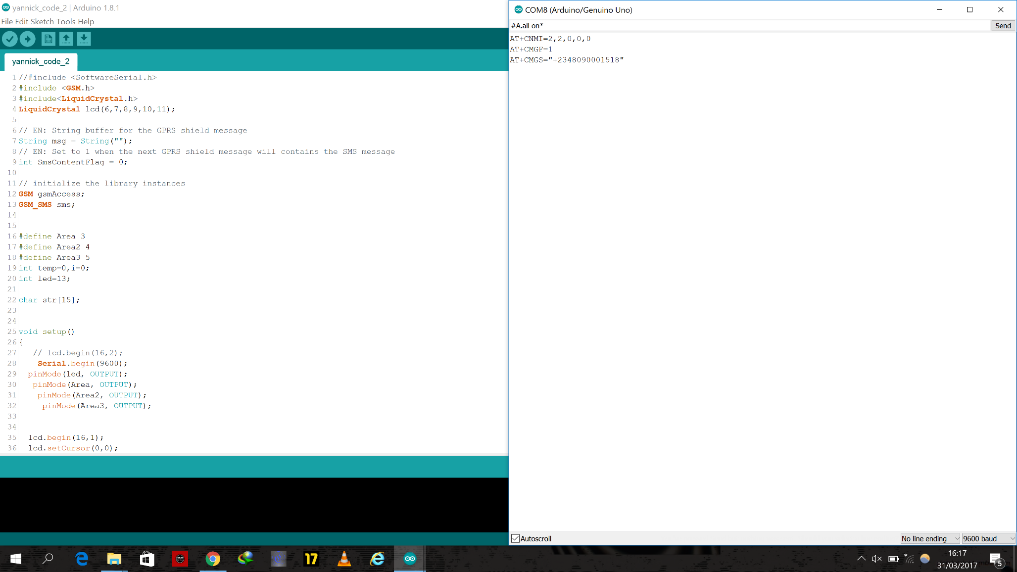

Figure 4.1 A screenshot of Code testing using Serial Monitor on the Arduino IDE

* + - 1. **Schematic Testing**

This entails using schematic software, such as Proteus 8, Fritzing amongst others to test the system design for functionality. It serves as a means of checking to see if there are flaws in the design before the acquisition stage thereby helping to save cost.

For this project, Proteus 8 was used and the GSM and Arduino libraries were downloaded from the internet and used.

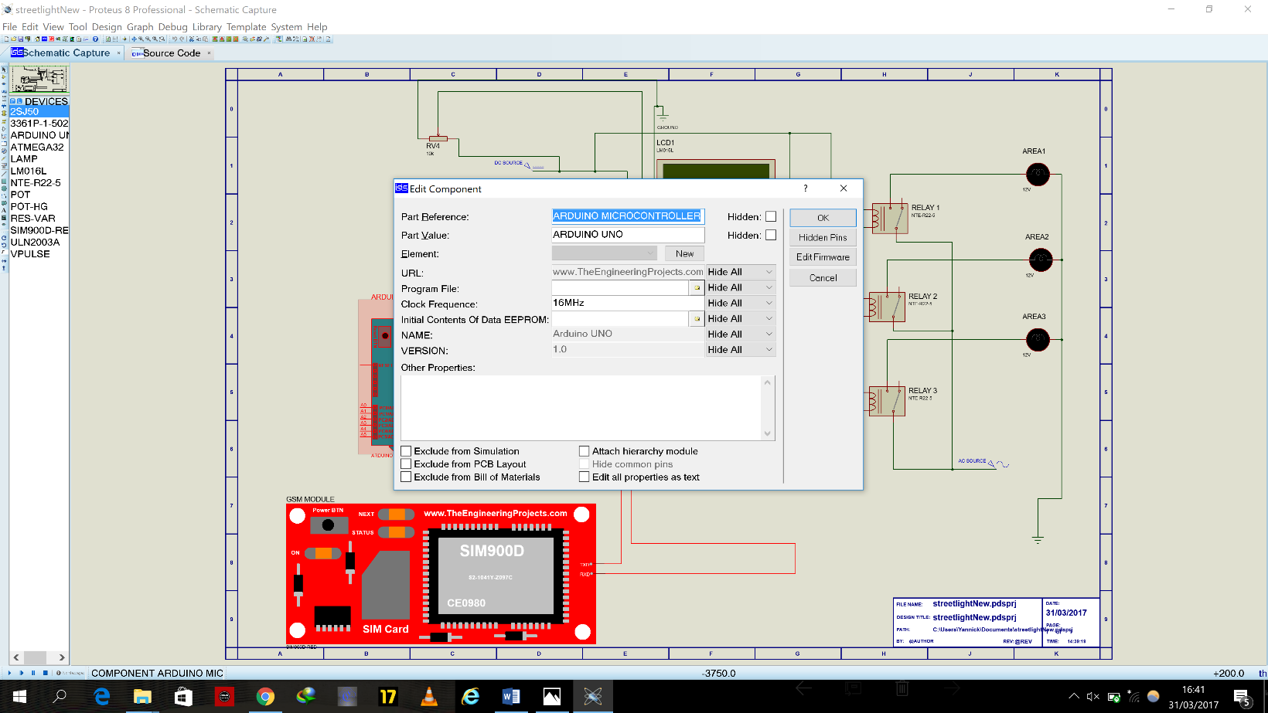

Figure 4.2 A screenshot showing use of Proteus 8 software to test the schematic

* + 1. **Hardware Testing**

Hardware testing entails testing the physical components which you can interact with.

The hardware testing carried out in this project are as follows.

* + - 1. **Unit Testing**

This involves testing each individual component, either for manufacturing errors or for continuity. The aim of component testing is to ensure every single component is working as expected. This testing can be carries out using a multimeter to test for continuity or with power supply to determine output power of the component. Every single component used in this project was first tested this way.

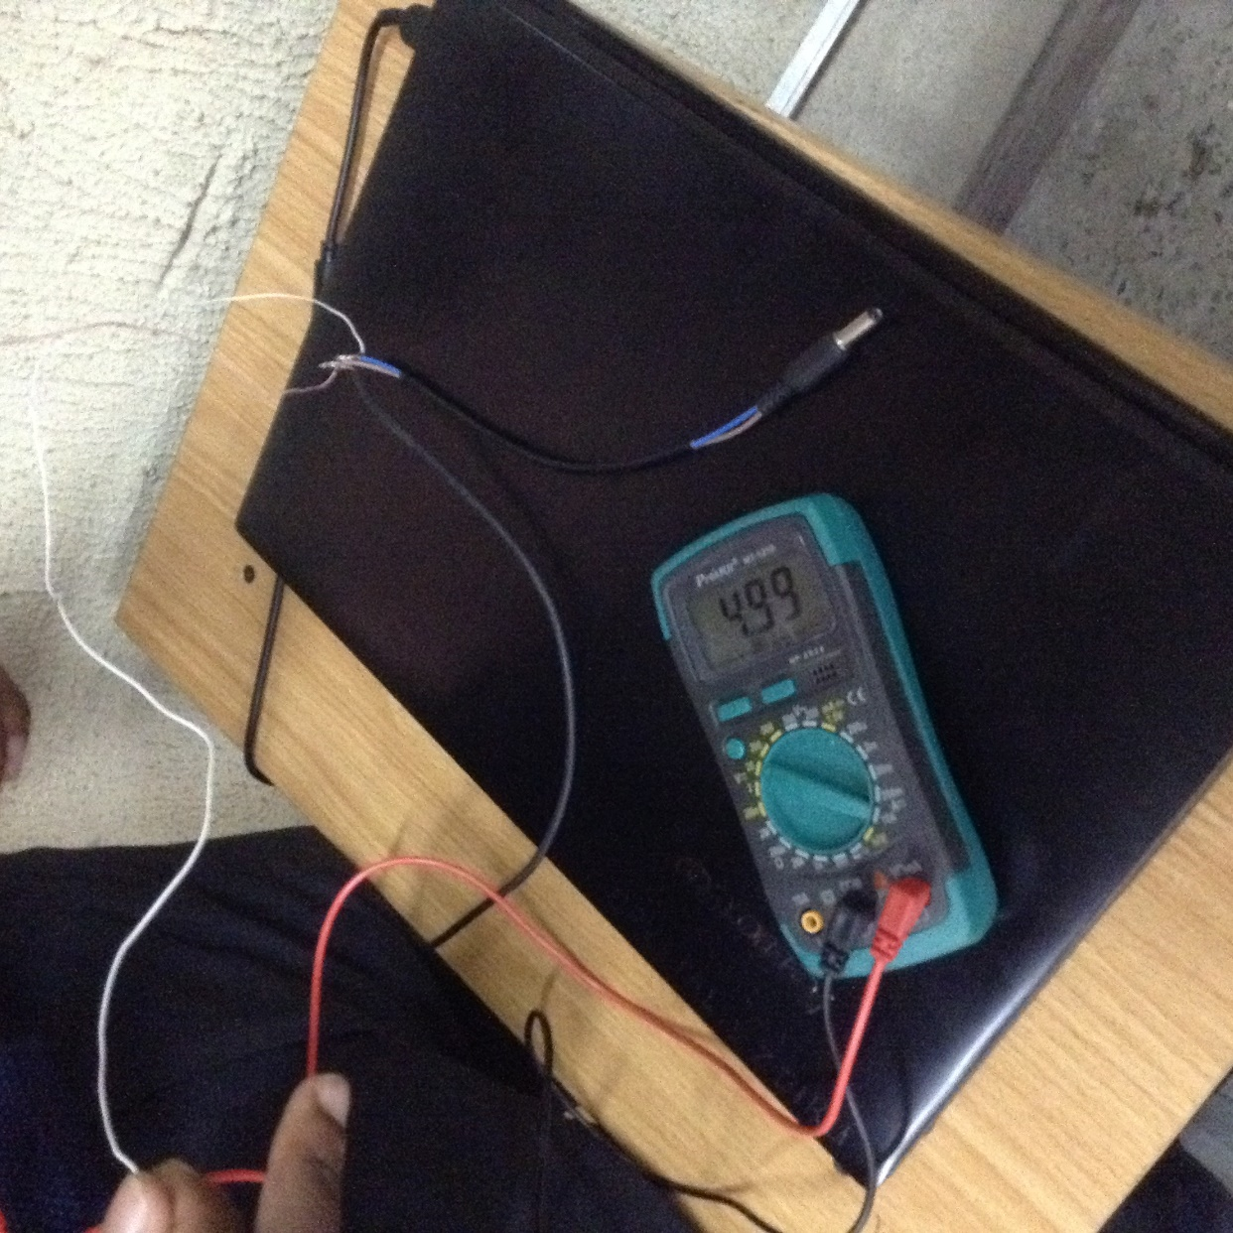

Figure 4.3 A picture of unit testing the GSM module power supply to ensure its up to 5V

* + - 1. **Integration Testing**

Integration testing has to do with testing of the complete system. Here the results obtained are compared to the objectives of the project and if they fulfil it, the system passes the test.

Each component is connected according to the system diagram and both the hardware and software must be working in tandem. It is the final testing that was done on the project.

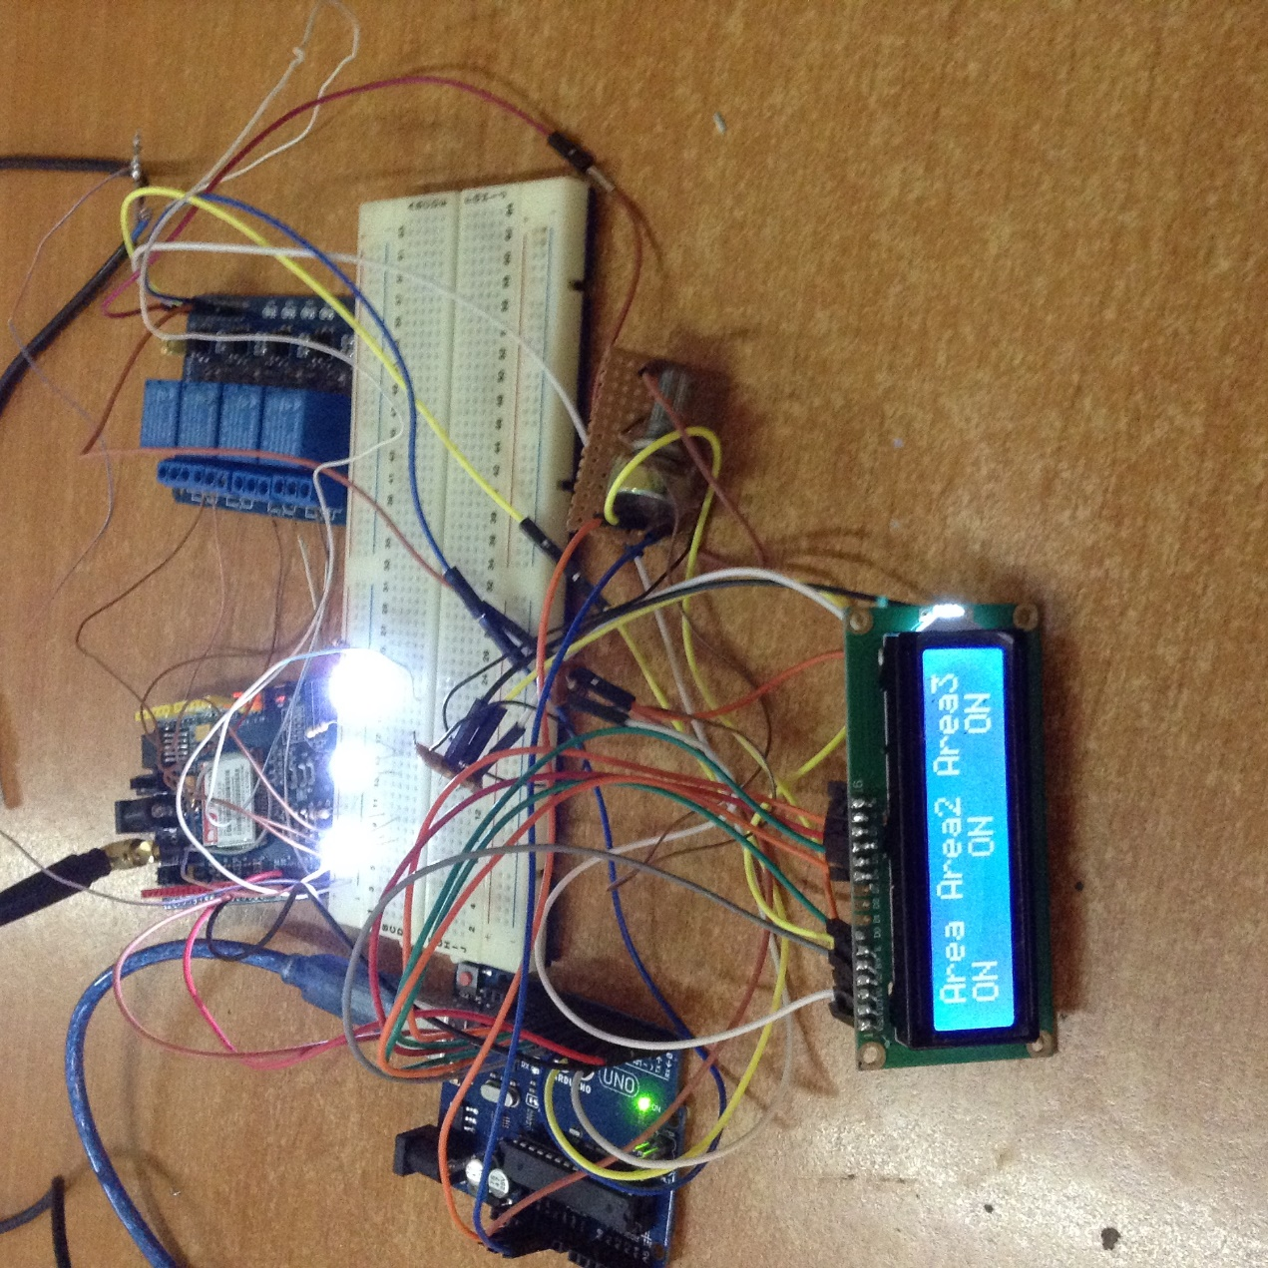

Figure 4.4 A picture showing the total system Integration Test

* 1. **Packaging**

The project was package using materials that ensure that the system will be protected both in storage and in use. Lightweight materials were chose in order to ensure the system isn’t too heavy in case of frequent movement.

* 1. **Bill of Engineering Measurement and Evaluation (BEME)**

Table 4.2 Bill of Engineering Measurement and Evaluation (BEME)

|  |  |  |  |  |
| --- | --- | --- | --- | --- |
| S/N | COMPONENTS | QUANTITY (N) | UNIT PRICE =N= | TOTAL  PRICE =N= |
| 1 | GSM Shield Sim900 | 1 | 13,000 | 13,000 |
| 2 | Arduino Uno R3 Microcontroller | 1 | 5,000 | 5,000 |
| 3 | LCD 16x2 | 1 | 1,000 | 1,000 |
| 4 | 12V DC plug adapter | 1 | 50 | 50 |
| 5 | Potentiometer (10K) | 1 | 80 | 80 |
| 6 | Relay 4 channel | 1 | 2,000 | 2,000 |
| 7 | 3mm LED | 6 | 20 | 120 |
| 8 | Power bank | 1 | 4000 | 4000 |
| 9 | DC power Supply (240/5V), 2A | 1 | 4000 | 4000 |
| 10 | Jumper Wires Male | 1 set | 800 | 800 |
| 11 | Jumper Wires Female | 1 set | 800 | 800 |
| 12 | Connector-Male Header | 2 set | 200 | 400 |
| 13 | Resistor (220 ohms) | 6 | 20 | 120 |
| 14 | Casing | 1 | 500 | 500 |
| 15 | USB cable | 1 | 1000 | 1000 |
|  |  |  | Total: | 32,870 |

* 1. **Observed Precautions**

Great care was taken during the course of implementing this project, this includes but is not limited to;

* I ensured I was familiar with the power ratings of each component in order to prevent blowing them up.
* I made sure I was careful when soldering in order to avoid bridging components.
* Each stage of the project was tested before moving to the next stage.

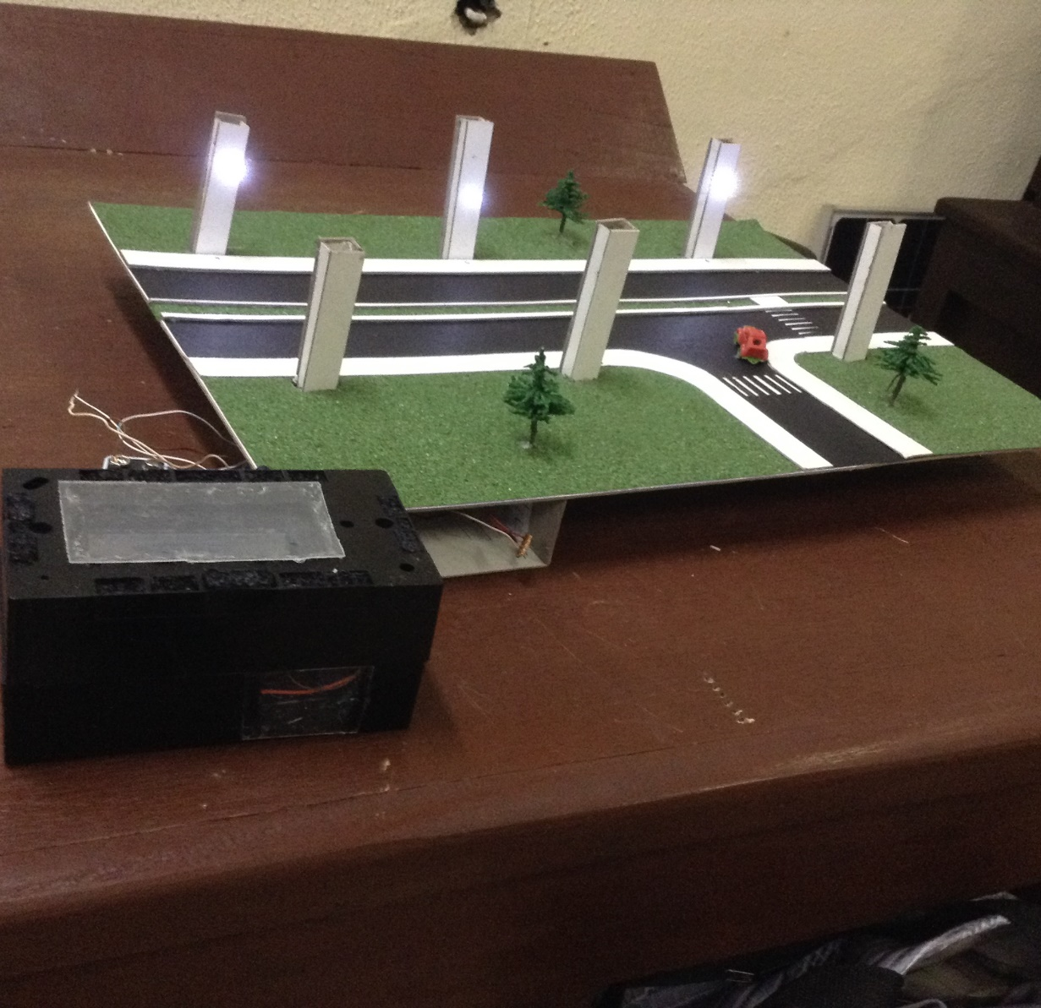

Figure 4.5 A picture showing the constructed working System.

* 1. **Conclusion**

In this chapter, the various details pertaining to the steps taken in implementing the system as well as testing them were revealed. The chapter highligts the steps taken to achieving project deliverables.

# **CHAPTER FIVE**

**CONCLUSION**

1. 1. **Summary**

This is the concluding chapter of the design and implementation of a GSM based Streetlight Automation system.

All the components required to implement a working model of the system were sourced for and successfully put together in accordance to the laid-out design.

* 1. **Ethical Considerations**

I can assert that this project has no ethical constraints as the entire project and all the components used in its execution pose no harm to humans or animals. The project is also environmental friendly as it does not have any negative effect on the environment.

This project is also free of electromagnetic radiation or any form of radiation.

* 1. **Achievements**

The project successfully designed and implemented a system that can remotely control streetlights with the use of SMS features of any GSM mobile from anywhere in the world. The project objectives were met and these included:

* Streetlight can be wirelessly controlled using GSM via SMS
* LCD monitor displays current state of system
* Because of more efficient control, there is increased power savings.
  1. **Challenges Encountered**

The challenges encountered in execution of this project include;

* Lack of previous experience with microcontroller functionality and usage.
* As a result of zero previous knowledge of micro-C, I spent a lot of development time debugging buggy code.
* Designing a single power supply for all the components proved difficult given the various voltage and current ratings.
* Difficulty of procurement of some components.
* Insufficient available literature on this model of GSM Sim900M shield.
  1. **Experience Gained**

During the course of designing and then execution of this project, I was exposed to and gained knowledge in areas such as;

* Introduction to microcontrollers.
* First taste of microcontroller programming.
* Experience of how to manage and execute a project from initialization to completion.
* Obtained knowledge on how to carry out detailed research in a subject area.
* I learnt how to divide a project into work pieces and how achieve goals using sub goal and sub deliverables.
  1. **Recommendations**

This developed system should be considered as a prototype, a model and not a compact system. This implies that evolution and improvement on this present system can still take place and is encouraged. Some of the ways this is possible include:

* Actual implementation would require more components and power considerations and thereby requiring more power supply.
* Motion Sensors may be introduced such that the level of illumination increases when human or vehicular motion is detected.
* A smart system can be employed using solar power in order to keep power concerns of the streetlighting off-grid.
* For a much larger area such as a housing estate, a streetlighting system could be executed using wireless technology rather than GSM.
  1. **Conclusion**

This project “GSM based streetlight automation system” was designed and produced in conformity with acceptable norms and standards with its primary aim of producing a simple system of automating streetlights, a system that was smart and enabled ease of use, saving the users time and effort by being able to be controlled from anywhere in the globe, reduction of power consumption, aided in power savings and contributed to the Internet of Things agenda of Covenant University. Whilst this model can be improved on as described in the recommendations part of this report, it also shows that execution of this project is not only doable, but it is also cheap, effective and efficient with regards to long term savings.

# **REFERENCES**

|  |  |
| --- | --- |
| [1] | A. K.SHEKAR, “Implementation of Power Saver Street Lighting and Automatic Traffic Management System,” *International Journal of Computer Science and Mobile Computing,* vol. 5, no. 1, 2016. |
| [2] | US Energy Information Administration, “FAQ,” US Energy Information Administration, [Online]. Available: https://www.eia.gov/tools/faqs/faq.cfm?id=99&t=3. [Accessed 4 November 2016]. |
| [3] | “How much does it really cost to light your office,” Bristol Daylighting Systems, [Online]. Available: http://www.bristolite.com/blog/how-much-does-it-really-cost-to-light-your-office/. [Accessed 4 November 2016]. |
| [4] | Madison gas and Electric Company, “Managing energy costs in office buildings,” [Online]. Available: https://www.mge.com/images/PDF/Brochures/business/ManagingEnergyCostsInOfficeBuildings.pdf. [Accessed 4 November 2016]. |
| [5] | Silver Spring Networks, “The Business Case for Smart Street Lights,” 2013. [Online]. Available: https://www.silverspringnet.com/article/executive-viewpoints/the-business-case-for-smart-street-lights/. [Accessed 13 December 2017]. |
| [6] | European PPP expertise center, “Energy Efficient Street Lighting,” 2015. [Online]. Available: https://www.google.com.ng/url?sa=t&rct=j&q=&esrc=s&source=web&cd=3&cad=rja&uact=8&ved=0ahUKEwjztc-o2Y_TAhVMCsAKHXzeDxQQFggvMAI&url=http%3A%2F%2Fwww.eib.org%2Fepec%2Fee%2Fdocuments%2Ffactsheet-street-lighting.pdf&usg=AFQjCNHlDo1dWg6b9wJ4kJRe4jHNGTs7YQ&sig2. [Accessed 10 December 2017]. |
| [7] | “Street light,” Wikipedia, [Online]. Available: https://en.wikipedia.org/wiki/Street_light. [Accessed 01 November 2016]. |
| [8] | “History of Street light,” History of lighting, [Online]. Available: http://www.historyoflighting.net/electric-lighting-history/history-of-street-lighting/. [Accessed November 01 2016]. |
| [9] | “Street Lighting,” Durban City Services, [Online]. Available: http://www.durban.gov.za/City_Services/electricity/Customer%20Care/Pages/Street-Lighting.aspx. [Accessed 30 10 2016]. |
| [10] | [Online]. Available: http://thelightingresource.eaton.com/features/2015/a-brief-history-of-street-lighting. [Accessed 2 November 2016]. |
| [11] | S. R. N. e. al, “GSM BASED AUTOMATION OF STREET LIGHT,” *International Journal of Innovative Science, Engineering & Technology,* vol. 1, no. 3, p. 3, 2014. |
| [12] | 1000 projects, “http://1000projects.org/automatic-street-light-controller-using-rtc.html,” 07 02 2012. [Online]. Available: http://1000projects.org/automatic-street-light-controller-using-rtc.html. [Accessed 04 03 2017]. |
| [13] | A. D. Y. e. al, “GSM Based Remote Control System of High Efficiency Intelligent Street Lighting System Using A Zigbee Network of Devices and Sensor,” *International Journal of Science and Research (IJSR),* no. 2319-7064, p. 4, 2012. |
| [14] | D. Kapgate, “Wireless Streetlight Control System,” *International Journal of Computer Applications,* vol. 41, no. 2, p. 7, 2012. |
| [15] | A. P. H. R. K. Chaitanya Amin, “GSM Based Autonomous Street Illumination System for Efficient Power Management,” *International Journal of Engineering Trends and Technology-,* vol. 4, no. 1, p. 7, 2013. |
| [16] | e. a. Nivetha S. R, *SMS based Wireless Notice board with Monitoring system,* Coimbatore, India: Electronics and Communication Engineering, Avinashilingam University. |
| [17] | G. P.Susmitha, “Design and Implementation of Weather Monitoring and Controlling System,” *International Journal of Computer Applications,* vol. 97, no. 3, p. 4, 2014. |
| [18] | “Development of a data acquisition and greenhouse control system based on GSM,” *International Journal of Engineering, Science and Technology,* vol. 3, no. 8, p. 2013, 10. |
| [19] | A. Y. H. S. S. D. Aman Singh, “GSM BASED SECURITY SYSTEM,” *International Journal of Advanced Technology in Engineering and Science,* vol. 2, no. 4, p. 4, 2014. |
| [20] | R. C. J. B. Tejonidhi Aphale, “Automated Toll Plaza Using RFID and GSM,” *International Journal on Recent and Innovation Trends in Computing and Communication,* vol. 2, no. 9, p. 4, 2014. |
| [21] | A. Sharma, *MICROCONTROLLER BASED LPG GAS DETECTOR USING GSM MODULE.* |
| [22] | A. Corporation, “Arduino Uno,” 2009. [Online]. Available: https://www.arduino.cc/en/main/arduinoBoardUno. [Accessed 12 February 2017]. |
| [23] | S. Corporation, “GSM Shield Sim900,” 2013. [Online]. Available: http://simcomm2m.com/En/module/detail.aspx?id=71. [Accessed 14 February 2017]. |
| [24] | Whatis.com, “What is an LCD,” [Online]. Available: http://whatis.techtarget.com/definition/LCD-liquid-crystal-display. [Accessed 1 March 2017]. |
| [25] | Geeteck, “What is a channel Relay Modulr,” Geeteck, [Online]. Available: http://www.geeetech.com/wiki/index.php/2-Channel_Relay_module. [Accessed 1 March 2017]. |
| [26] | WhatIs.com, “what is an LED,” TechTarget, [Online]. Available: http://whatis.techtarget.com/definition/light-emitting-diode-LED. [Accessed 12 March 2017]. |

**APPENDIX**

**Software Codes**

#include <GSM.h>

#include<LiquidCrystal.h>

LiquidCrystal lcd(6,7,8,9,10,11);

// EN: String buffer for the GPRS shield message

String msg = String("");

// EN: Set to 1 when the next GPRS shield message will contains the SMS message

int SmsContentFlag = 0;

// initialize the library instances

GSM gsmAccess;

GSM_SMS sms;

#define Area 3

#define Area2 4

#define Area3 5

int temp=0,i=0;

int led=13;

char str[15];

void setup()

{

Serial.begin(9600);

pinMode(led, OUTPUT);

pinMode(Area, OUTPUT);

pinMode(Area2, OUTPUT);

pinMode(Area3, OUTPUT);

lcd.begin(16,1);

lcd.setCursor(0,0);

for (int positionCounter = 0; positionCounter < 25; positionCounter++){

lcd.scrollDisplayLeft();

lcd.print(" Gsm Based StreetLight Automation System");

delay(300);

}

lcd.clear();

lcd.begin(16,2);

lcd.setCursor(0,0);

lcd.print("By Yannick Dongo");

lcd.setCursor(0,1);

lcd.print(" 12CK013851 ");

delay(3000);

lcd.clear();

lcd.setCursor(0,1);

lcd.print("System Ready");

Serial.println("AT+CNMI=2,2,0,0,0");

delay(500);

Serial.println("AT+CMGF=1");

Serial.print("AT+CMGS=\"+2348090001518\"\r");

delay(1000);

lcd.clear();

lcd.setCursor(0,0);

lcd.print("Area Area2 Area3 ");

lcd.setCursor(0,1);

lcd.print("OFF OFF OFF ");

}

void loop()

{

lcd.setCursor(0,0);

lcd.print("Area Area2 Area3");

if(temp==1)

{

check();

temp=0;

i=0;

delay(1000);

}

}

void serialEvent()

{

while(Serial.available())

{

if(Serial.find("#A."))

{

digitalWrite(led, HIGH);

delay(1000);

digitalWrite(led, LOW);

while (Serial.available())

{

char inChar=Serial.read();

str[i++]=inChar;

if(inChar=='*')

{

temp=1;

return;

}

}

}

}

}

void check()

{

if(!(strncmp(str,"Area3 on",5)))

{

digitalWrite(Area3, HIGH);

lcd.setCursor(13,1);

lcd.print("ON ");

delay(200);

}

else if(!(strncmp(str,"Area3 off",6)))

{

digitalWrite(Area3, LOW);

lcd.setCursor(13,1);

lcd.print("OFF ");

delay(200);

}

else if(!(strncmp(str,"Area on",5)))

{

digitalWrite(Area, HIGH);

lcd.setCursor(0,1);

lcd.print("ON ");

delay(200);

}

else if(!(strncmp(str,"Area off",7)))

{

digitalWrite(Area, LOW);

lcd.setCursor(0,1);

lcd.print("OFF ");

delay(200);

}

else if(!(strncmp(str,"Area2 on",8)))

{

digitalWrite(Area2, HIGH);

lcd.setCursor(7,1);

lcd.print("ON ");

delay(200);

}

else if(!(strncmp(str,"Area2 off",9)))

{

digitalWrite(Area2, LOW);

lcd.setCursor(7,1);

lcd.print("OFF ");

delay(200);

}

else if(!(strncmp(str,"all on",6)))

{

digitalWrite(Area2, HIGH);

digitalWrite(Area, HIGH);

digitalWrite(Area3, HIGH);

lcd.setCursor(0,1);

lcd.print("ON ON ON ");

delay(200);

}

else if(!(strncmp(str,"all off",7)))

{

digitalWrite(Area2, LOW);

digitalWrite(Area, LOW);

digitalWrite(Area3, LOW);

lcd.setCursor(0,1);

lcd.print("OFF OFF OFF ");

delay(200);

}

}